|  |  |
| --- | --- |
| **Digital Forensics**  Diploma in CSF/IT  Year 3 (2023/24) Semester 4/6 | Week 3-17 |
|  |
| **Write-up on Open Source Forensic Tools - Individual** | |

|  |  |  |
| --- | --- | --- |
| Student No. | Student Name | Tutorial Group |
| S10241971 | Huang Wen |  |

## Name and description of Open Source Tool(s):

You should research on at least one open source forensic tool.

You should include information such as:

* Functionalities of the tool(s).
* How each function listed can help in your forensic investigation?
* Any other similar tool.
* Reason(s) why this tool is chosen.

## Description of demonstration:

*Describe clearly how you intend to perform the demonstration using the above tool(s). Your description should include:*

* *Case Description*
  + What happened?
  + Who is the suspect?
  + Who is the victim?
* *Source of evidence files (to create on your own, download from a website, etc.?)*
* *How do you plan to create the evidence?*
* *Physical setup (with a list of resources) for the demo.*
* *Other details such as diagram, activity flow chart.*

Note:

You are required to demonstrate the above tool(s) during week 16/17. Change of tools will only be allowed if it is approved by your tutor.

Contents

Name and description of Open Source Tool(s): 1

Description of demonstration: 1

1. Tool Used 3

2. Functionality of tools and how they help in my forensic investigation. 3

2.1. Mmls 3

2.2. fsstat 4

2.3. FLS 6

2.4. tsk_recover 8

2.5. Other useful commands 9

2.5.1. Blkcat 9

2.5.2. Ifind 9

2.5.3. Istat 9

2.5.4. Mactime 10

3. Similar tool 11

4. Reasons for the tool 11

5. Tool Used 12

6. Functionality of tools and how they help in my forensic investigation. 12

6.1. Ewfinfo 12

6.2. Ewfmount 14

7. Tool Used 16

8. Functionality of tools and how they help in my forensic investigation. 16

8.1. Find and Grep 16

9. Tool Used 17

10. Functionality of tools and how they help in my forensic investigation. 17

10.1. Stegseek 17

11. Similar tool 18

12. Reasons for the tool 18

13. Tool Used 18

14. Functionality of tools and how they help in my forensic investigation. 18

14.1. fidentify 18

15. Similar tool 19

16. Tool Used 19

17. Functionality of tools and how they help in my forensic investigation. 19

17.1. foremost 19

18. Similar tool 20

19. Reasons for the tool 20

20. Tool Used 20

21. Functionality of tools and how they help in my forensic investigation. 21

21.1. Exiftool 21

Read and write meta information in files. 21

22. Similar tool 24

23. Reasons for the tool 24

24. Other tools 24

24.1. Hexeditor 25

24.2. Sqlitebrowser 25

24.3. John 26

25. Reference 26

26. Description of Demonstration 27

26.1. Case scenario 27

26.2. Source of evidence file 28

26.3. How to create the evidence file 28

# Tool Used

The open-source forensic tool that I will be researching for this assignment is The Sleuth Kit, also known as TSK. It is a collection of UNIX-based command line file and volume system forensic analysis tools.

# Functionality of tools and how they help in my forensic investigation.

## Mmls

Display essential information about the organization of partitions, including details on the starting, ending sectors, description and size of each partition.

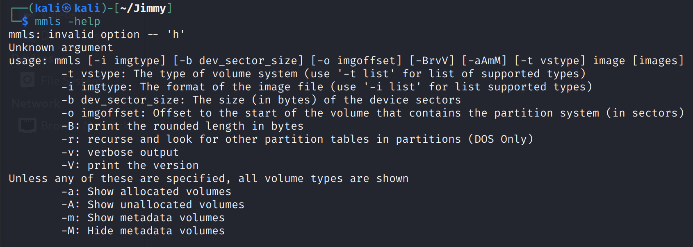

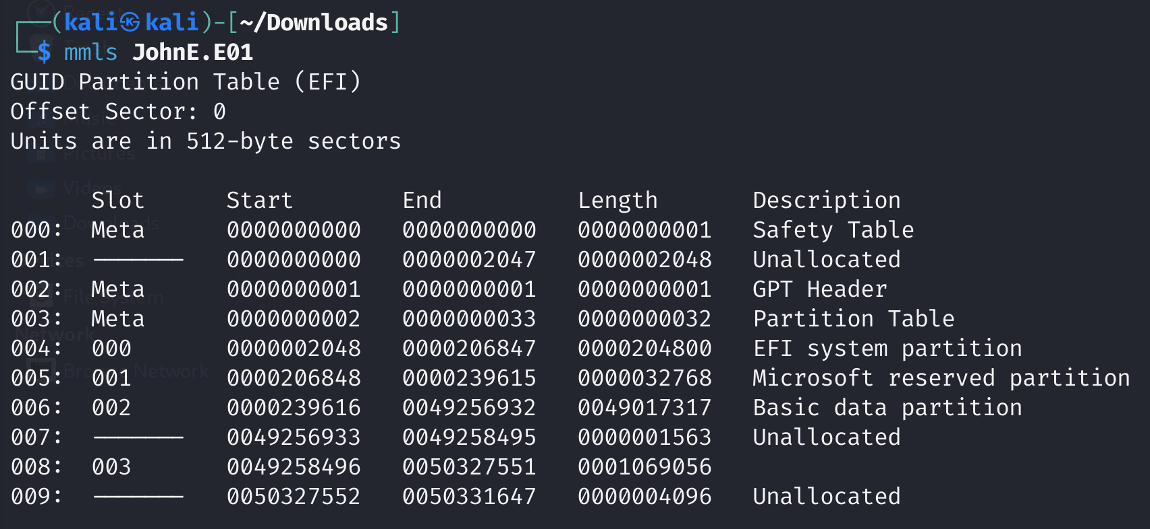

It provides a comprehensive view of the partition layout on a storage device or disk image. The information provided helps in partition identification, focusing on partition that stores user information and ignore other partition that is irrelevant to the investigation. The starting sector of the partition is important for us as we need it to navigate to the partition when calling other commands in the later section.

## fsstat

Display comprehensive overview of statistics, including information on the file system type, layout, inode and block usage, and specific features such as journaling support.

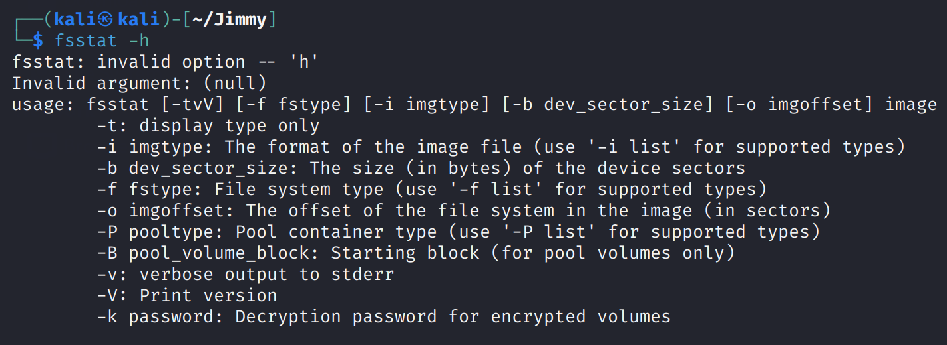

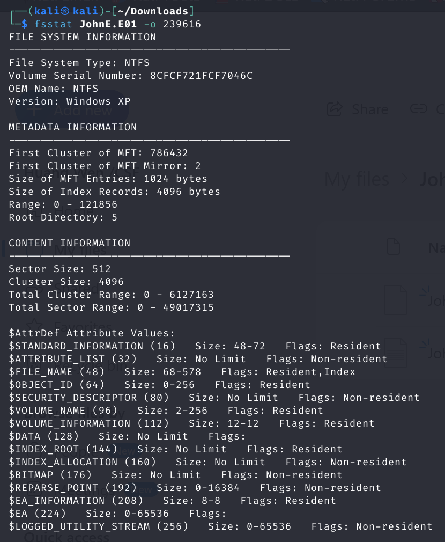

This function aids us in understanding the overall organization and information of the file system they are analyzing, allowing us to navigate digital evidence more effectively.

It also provides details regarding size of sector and cluster, and $MFT Attributes. This information is invaluable for assessing the file system's capacity, utilization, and potential areas of interest for further investigation. Moreover, fsstat assists us in understanding the features supported by the file system, which is crucial for tailoring forensic methodologies to the specific characteristics of the file system being examined.

## FLS

List file and directory names in a disk image and display file names of recently deleted files for the directory using then given inode. This command can display the mactime of the files using the -m flag. The mactime file can be used for commands in the later section to create a timeline.

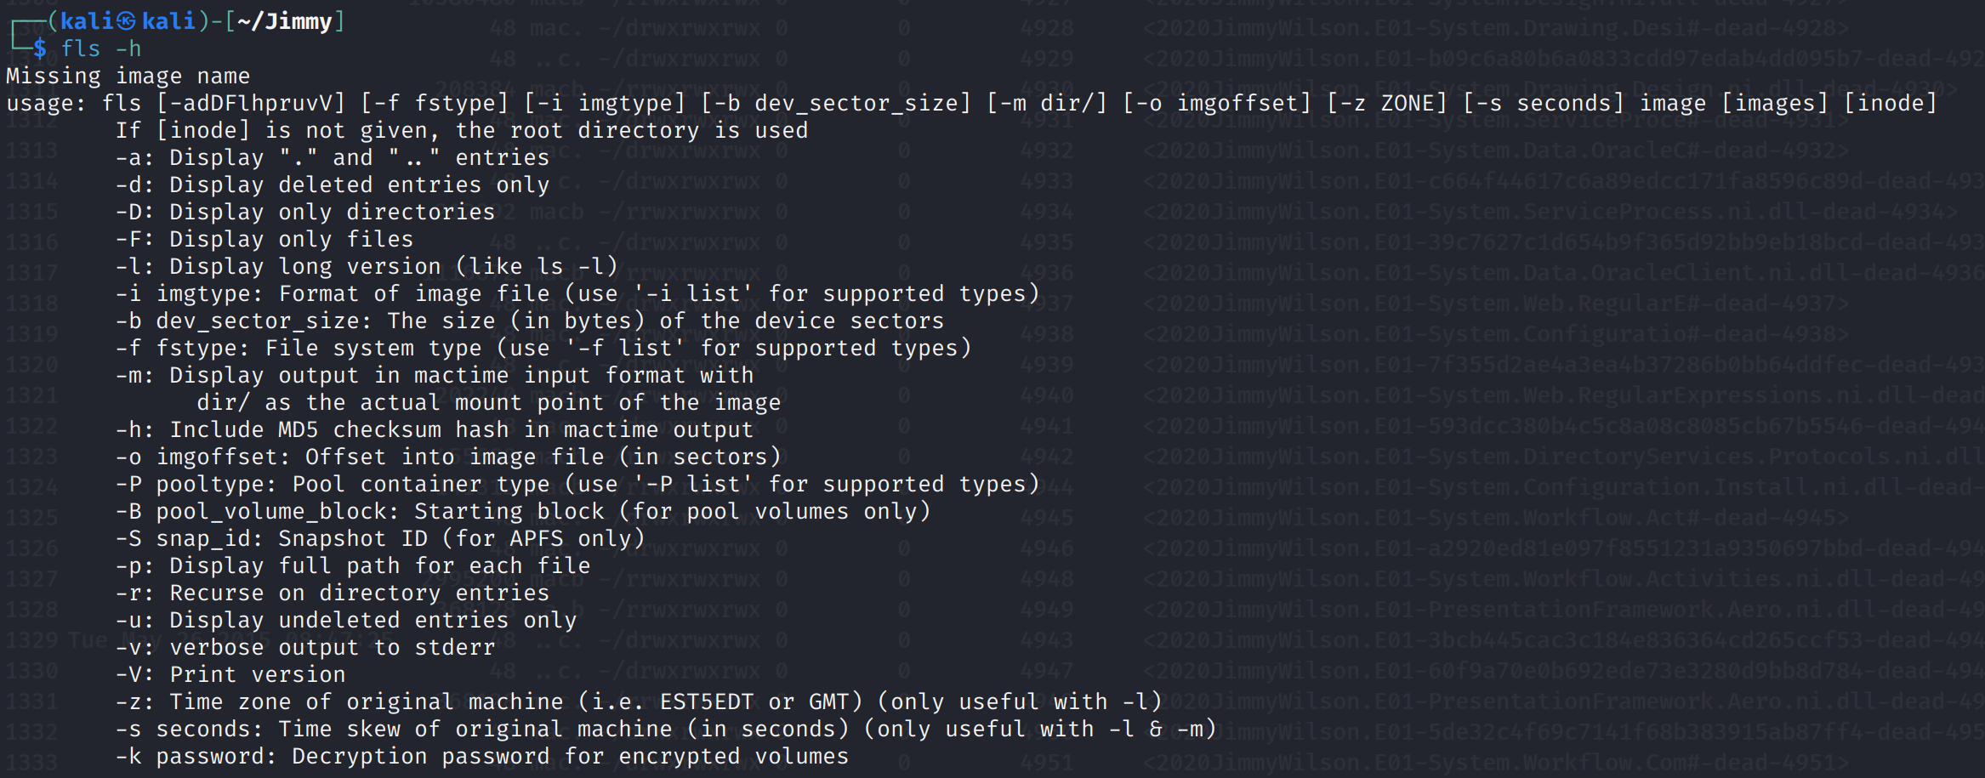

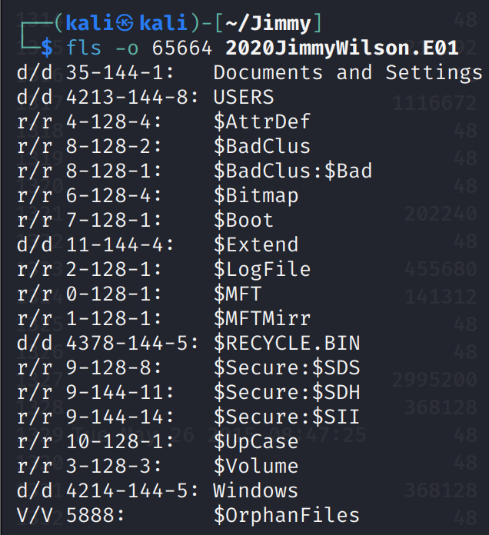

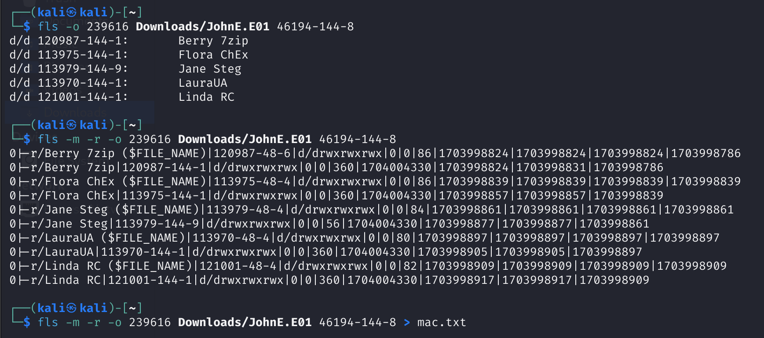

Helps us in conducting file hierarchy analysis, enabling them to understand the organizational structure of the digital evidence. The command facilitates the identification of potentially relevant areas for further investigation, allowing us to navigate through the file system with precision.

With features like recursive listing, fls can efficiently explore the entire file system structure, providing a holistic view of files and directories, including those within subdirectories. The cross-platform compatibility of fls ensures its adaptability to various file system types, making it a versatile feature for investigations involving evidence from diverse sources and operating systems.

## tsk_recover

Export files from an image into a local directory.

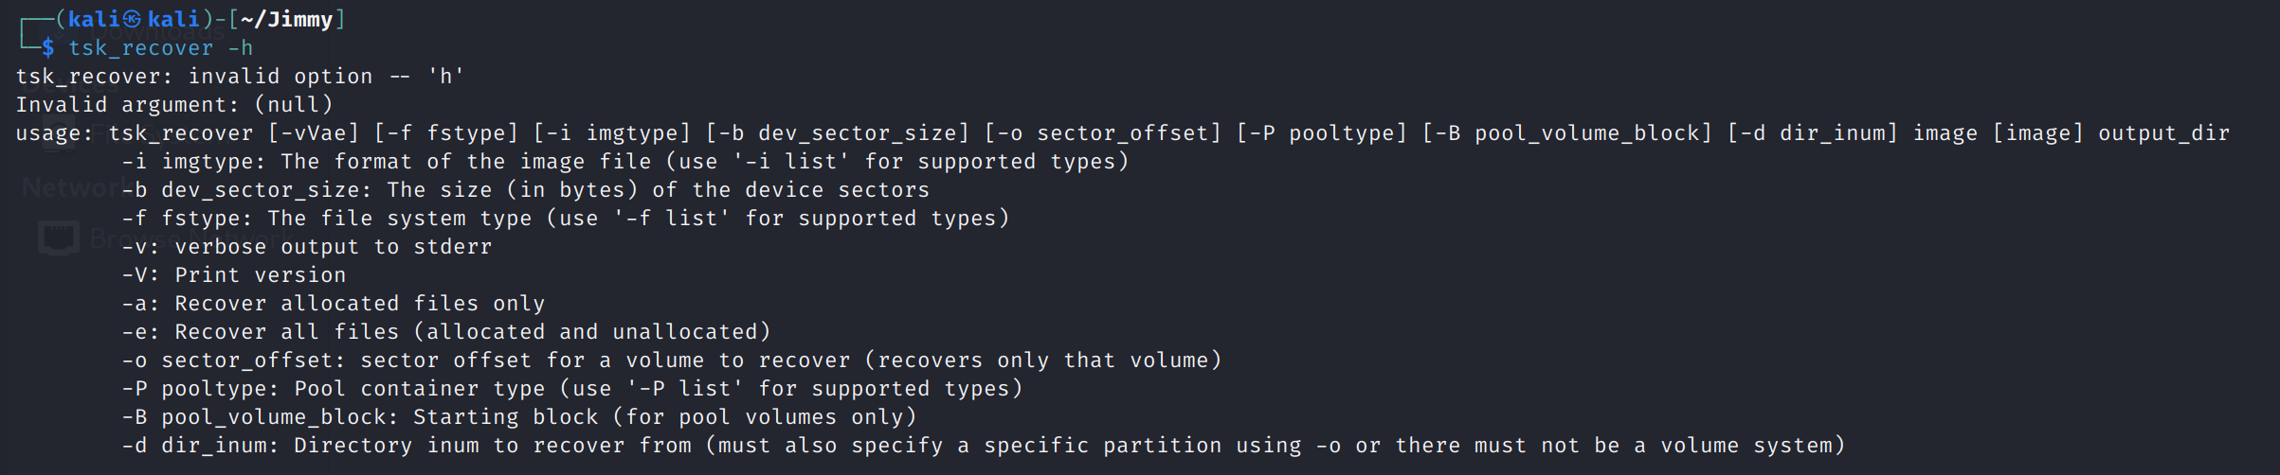

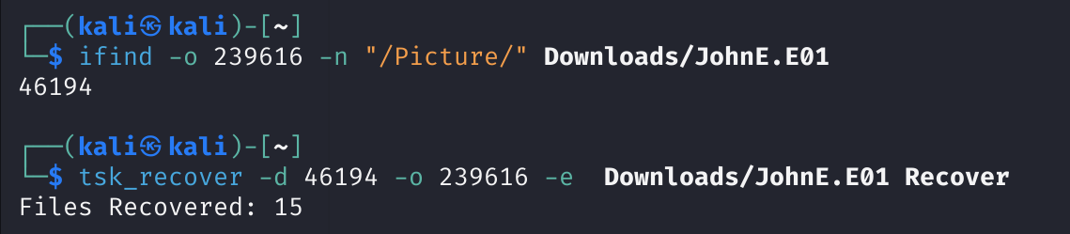

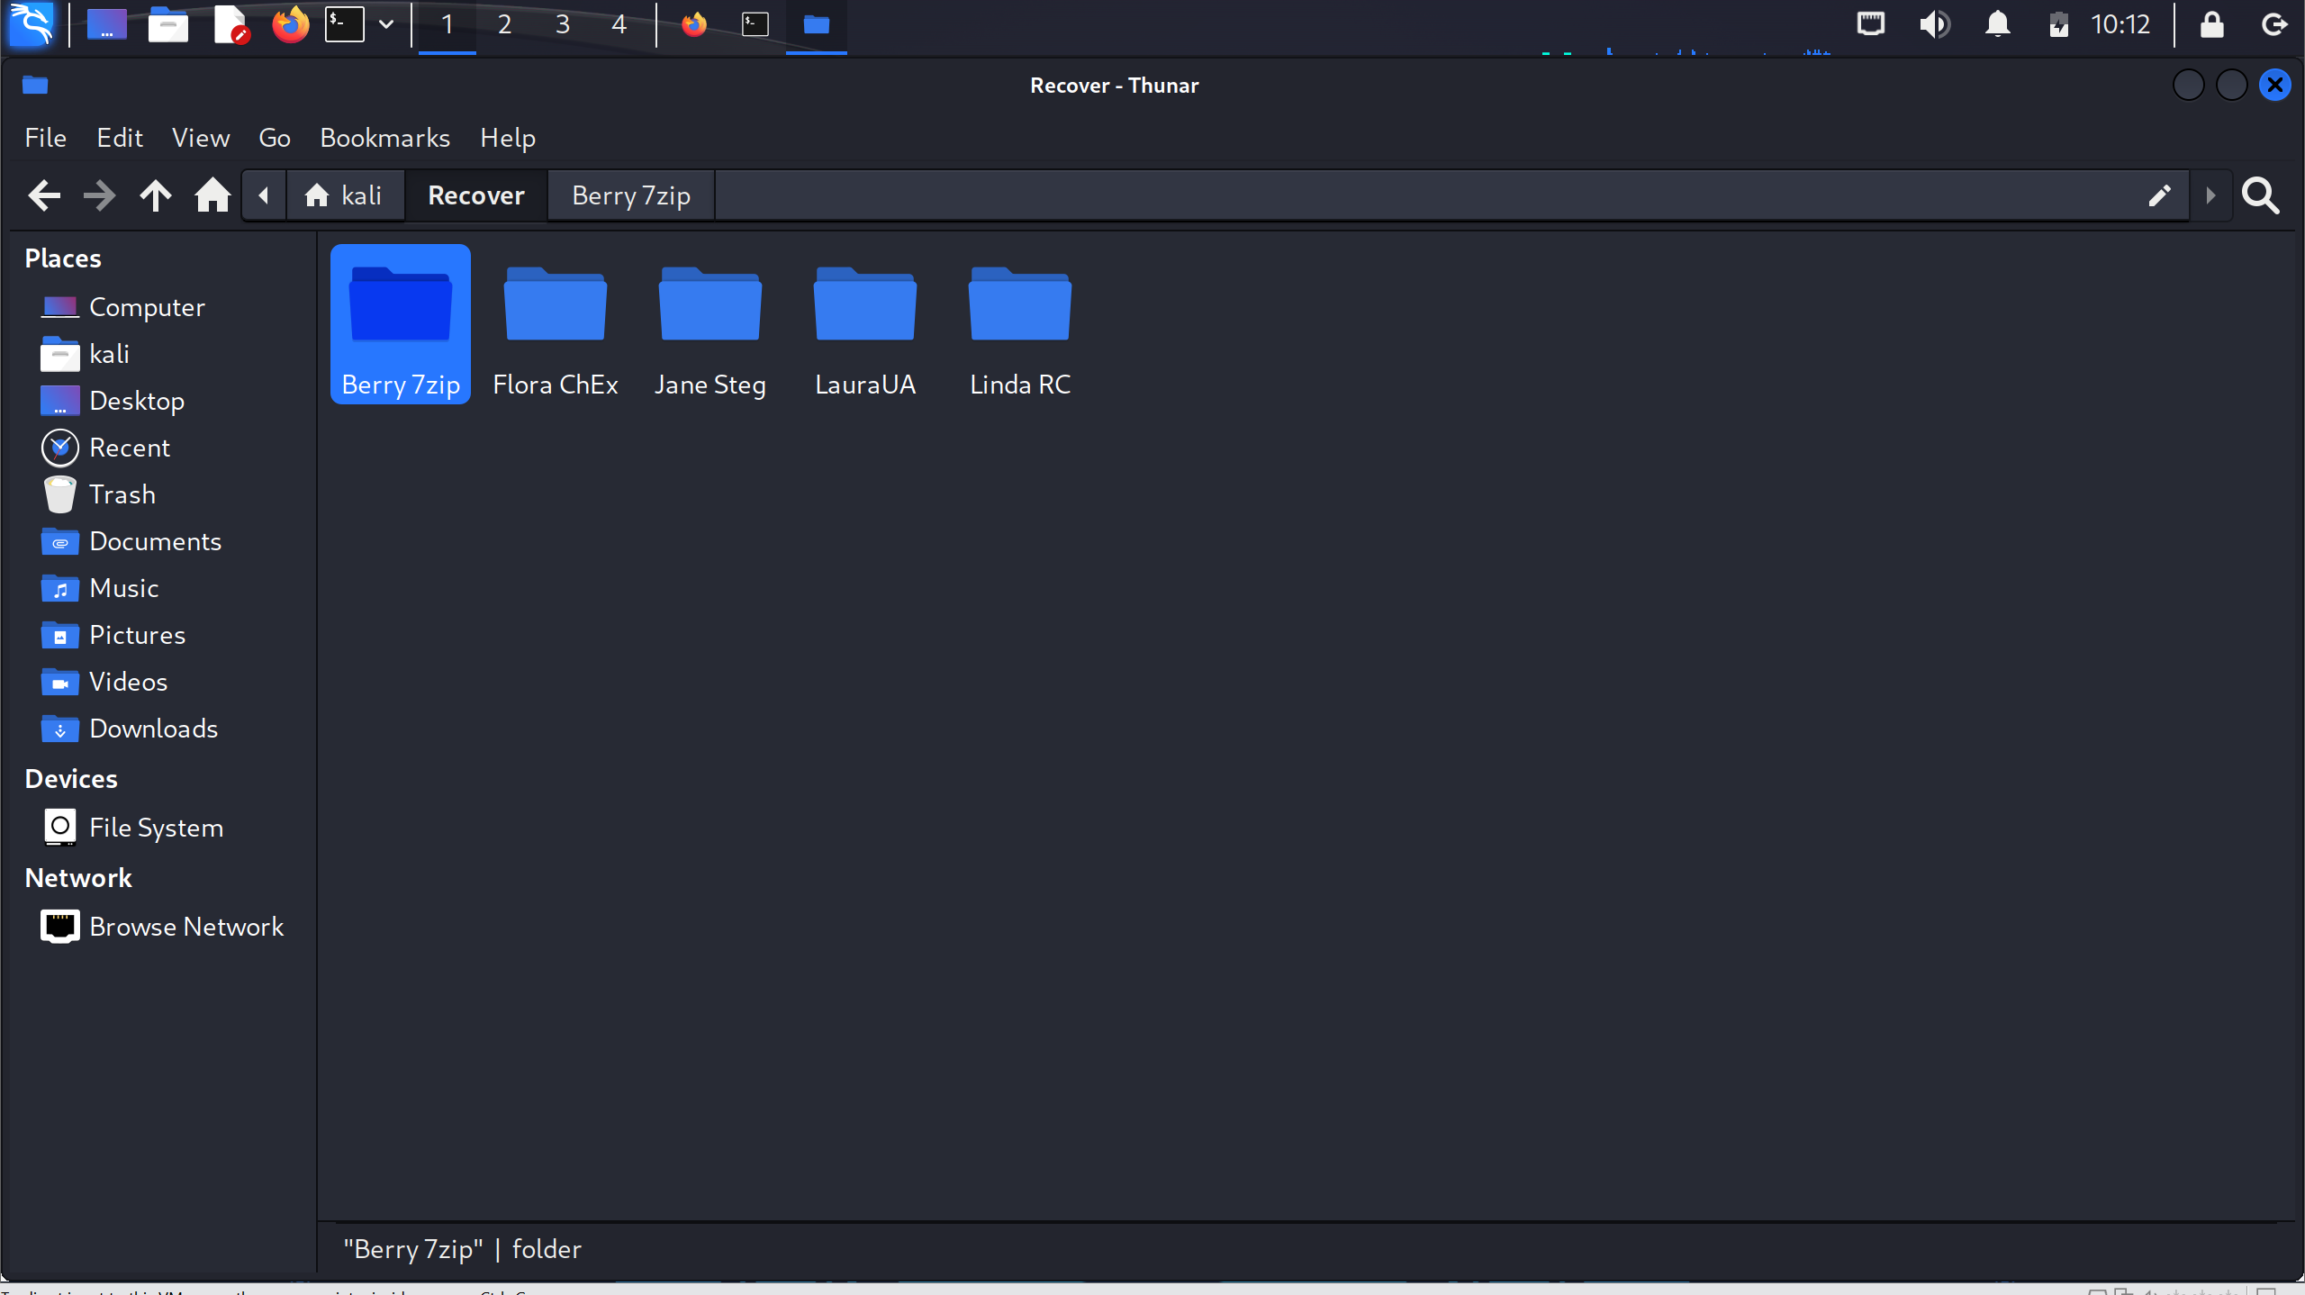

We benefit significantly from tsk_recover in several ways. It facilitates the extraction of files that may have been intentionally or unintentionally deleted, providing a comprehensive view of the suspect's activities. This recovered data is instrumental in reconstructing timelines, understanding suspect actions, and uncovering potentially critical evidence. The command's ability to recover both allocated and unallocated files caters to different forensic needs, allowing us to delve into the entirety of digital evidence present in the image.

## Other useful commands

### Blkcat

Display the contents of file system data unit in a disk image.

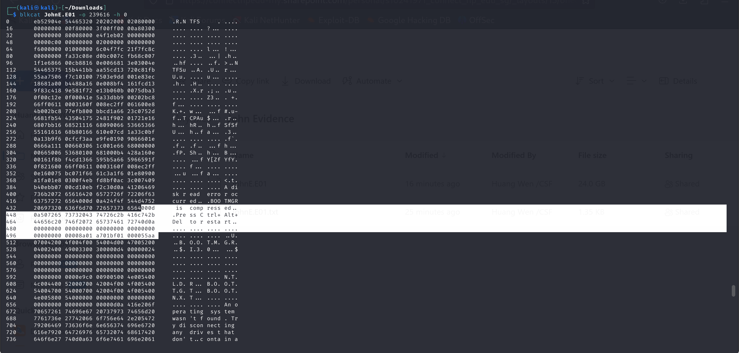

This function displays the content of the disk in hexeditor manner by provide the offset. It can show contents like MBR, which cannot be found using fls commands.

### Ifind

Find the meta-data structure that has allocated a given disk unit or file name.

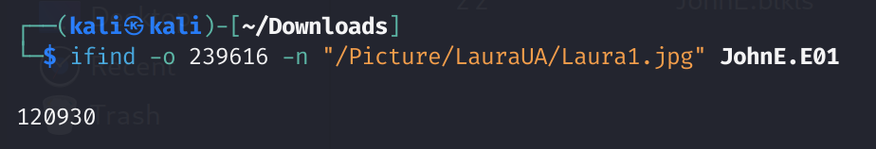

Produce the inode number of the file that can be used in the command istat to locate the file.

### Istat

Display details of a meta-data structure (i.e. inode)

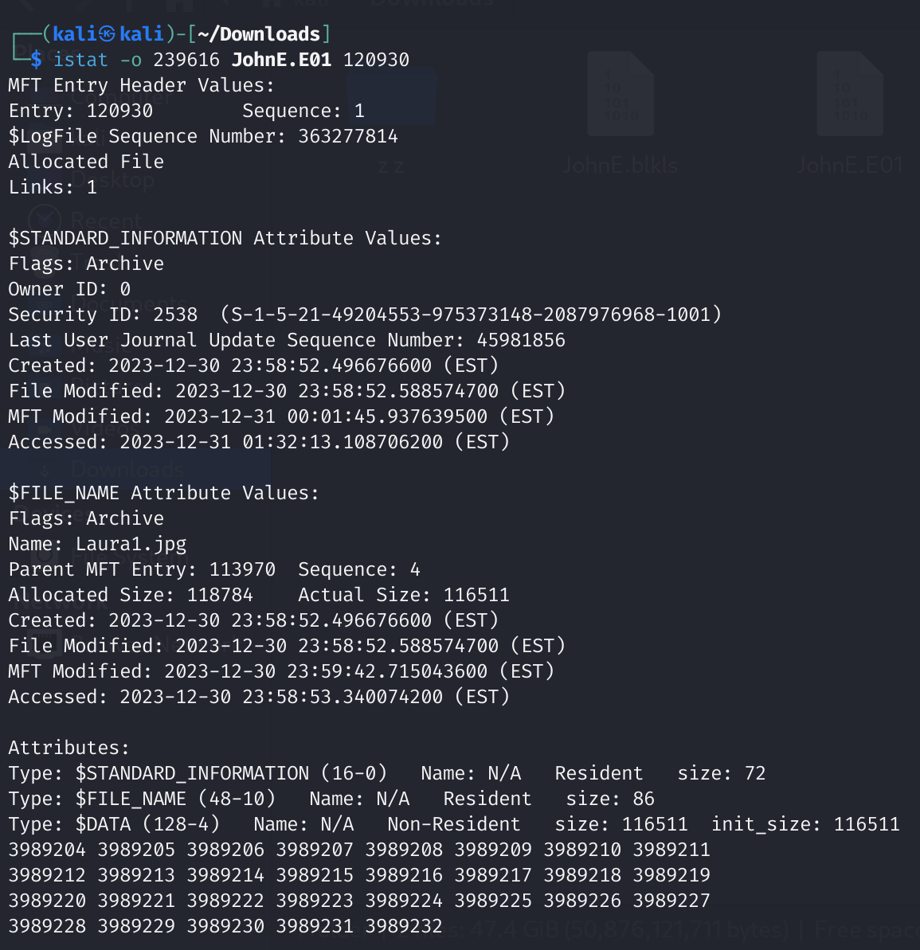

It shows the MFT information relating to the file, such as MACE timestamp.

### Mactime

Creates an ASCII timeline of file activity.

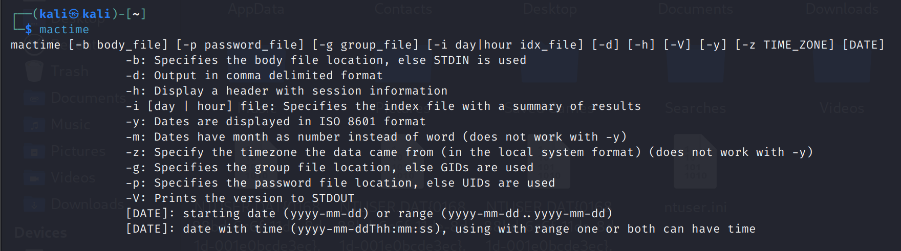

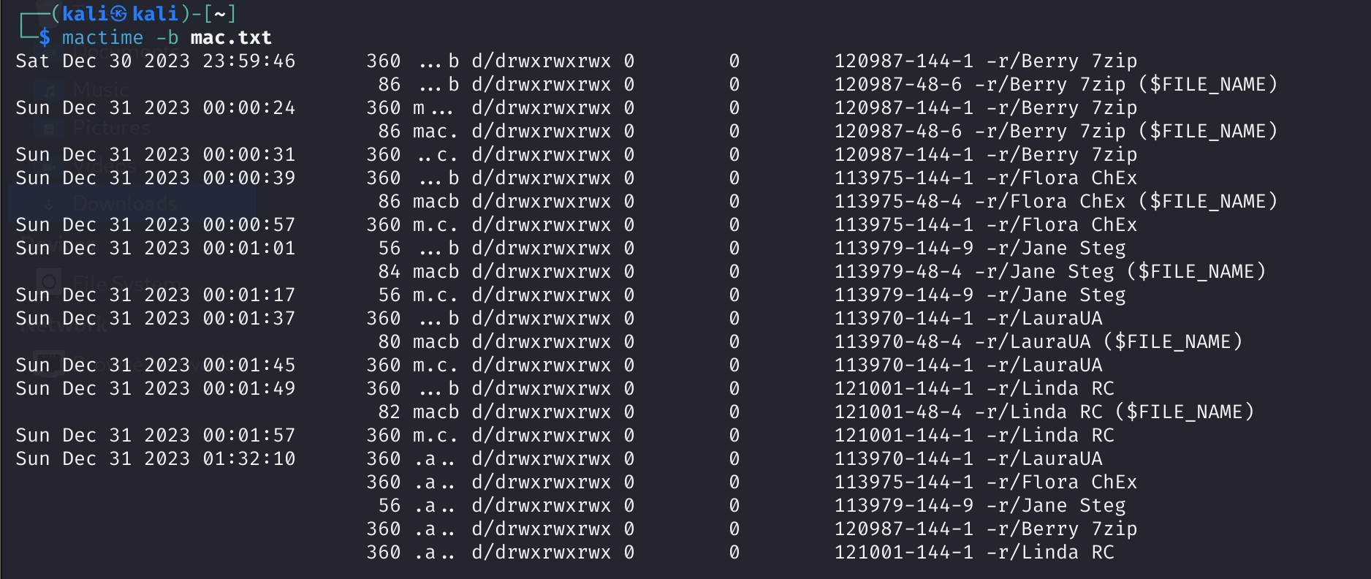

It helps us to gain more information about the files, such as time-related aspects.

# Similar tool

One similar tool is bulk extractor.

Bulk Extractor

bulk_extractor is a C++ program that scans a disk image, a file, or a directory of files and extracts useful information without parsing the file system or file system structures. The results are stored in feature files that can be easily inspected, parsed, or processed with automated tools. bulk_extractor also creates histograms of features that it finds, as more common features tend to be more important.

# Reasons for the tool

This tool is employed for its ability to examine suspect computer filesystems in a non-intrusive fashion. As it does not rely on the operating system to process the file systems, deleted and hidden content is shown. Compatible with both Windows and Unix platforms.

The tool's versatility extends to handling DOS partitions, BSD partitions (disk labels), Mac partitions, Sun slices (Volume Table of Contents), and GPT disks. It accommodates various input data formats like raw (e.g., dd extension), Expert Witness (e.g., EnCase), and AFF filesystem and disk images. Furthermore, it offers support for diverse file systems, including NTFS, FAT, ExFAT, UFS 1, UFS 2, EXT2FS, EXT3FS, Ext4, HFS, ISO 9660, and YAFFS2, even if the host operating system (Kali Linux in this case) does not or has a different endian ordering.

An additional benefit is its open-source nature, making it easily accessible by everyone, and its continuous updates, with the most recent one dating back to August 30.

# Tool Used

Libewf is a library with support for reading and writing the Expert Witness Compression Format (EWF). This library allows you to read media information of EWF files in the SMART (EWF-S01) format and the EnCase (EWF-E01) format. It supports files created by EnCase 1 to 6, linen and FTK Imager. The libewf is useful for forensics investigations.

# Functionality of tools and how they help in my forensic investigation.

## Ewfinfo

Show meta data stored in EWF files.

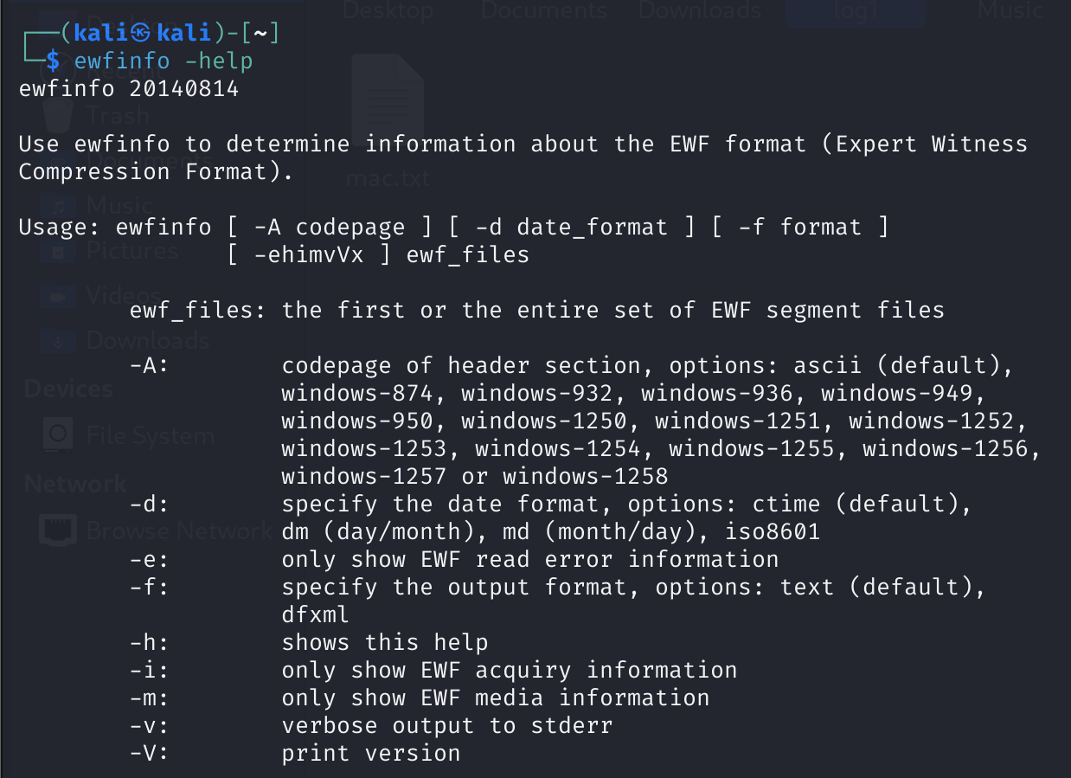

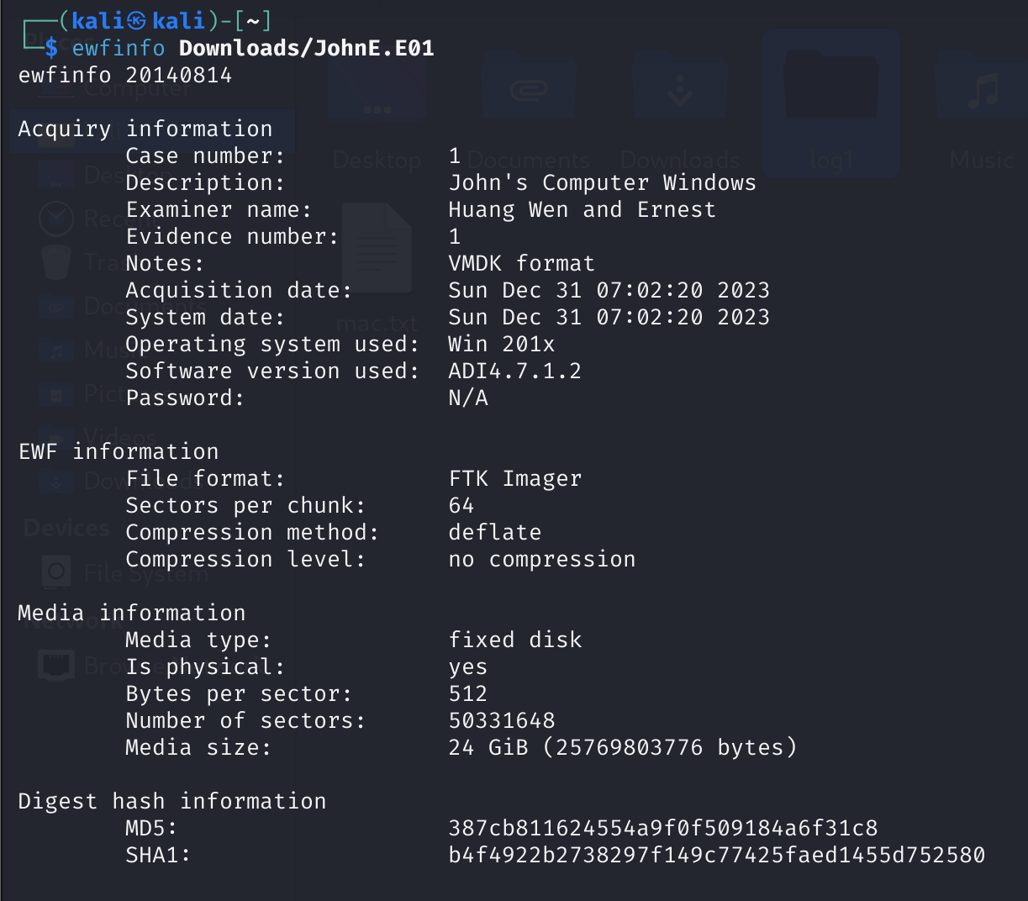

We can use this command to get the hash value of the evidence file, to verify the integrity of the file.

## Ewfmount

Mount data stored in EWF files

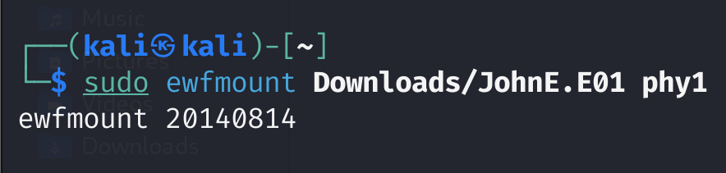

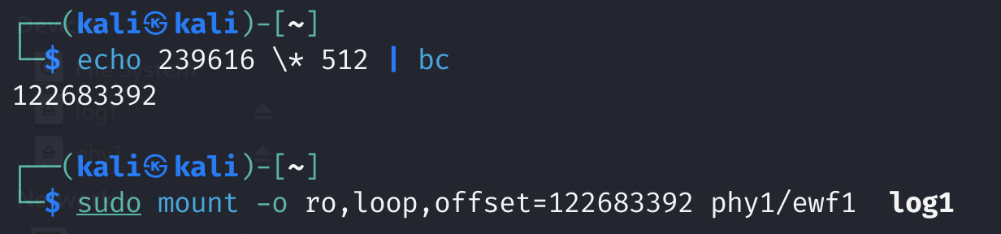

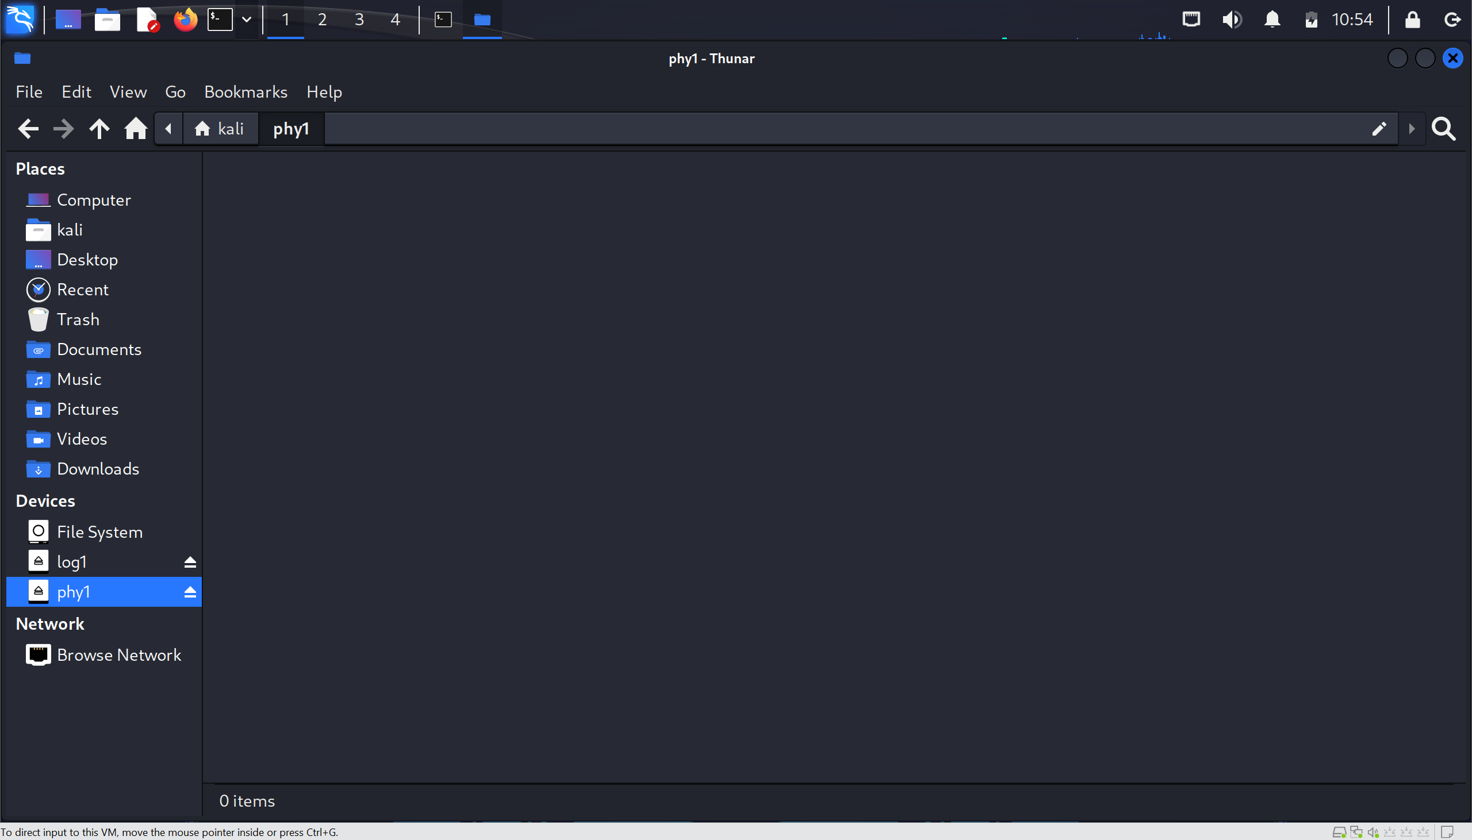

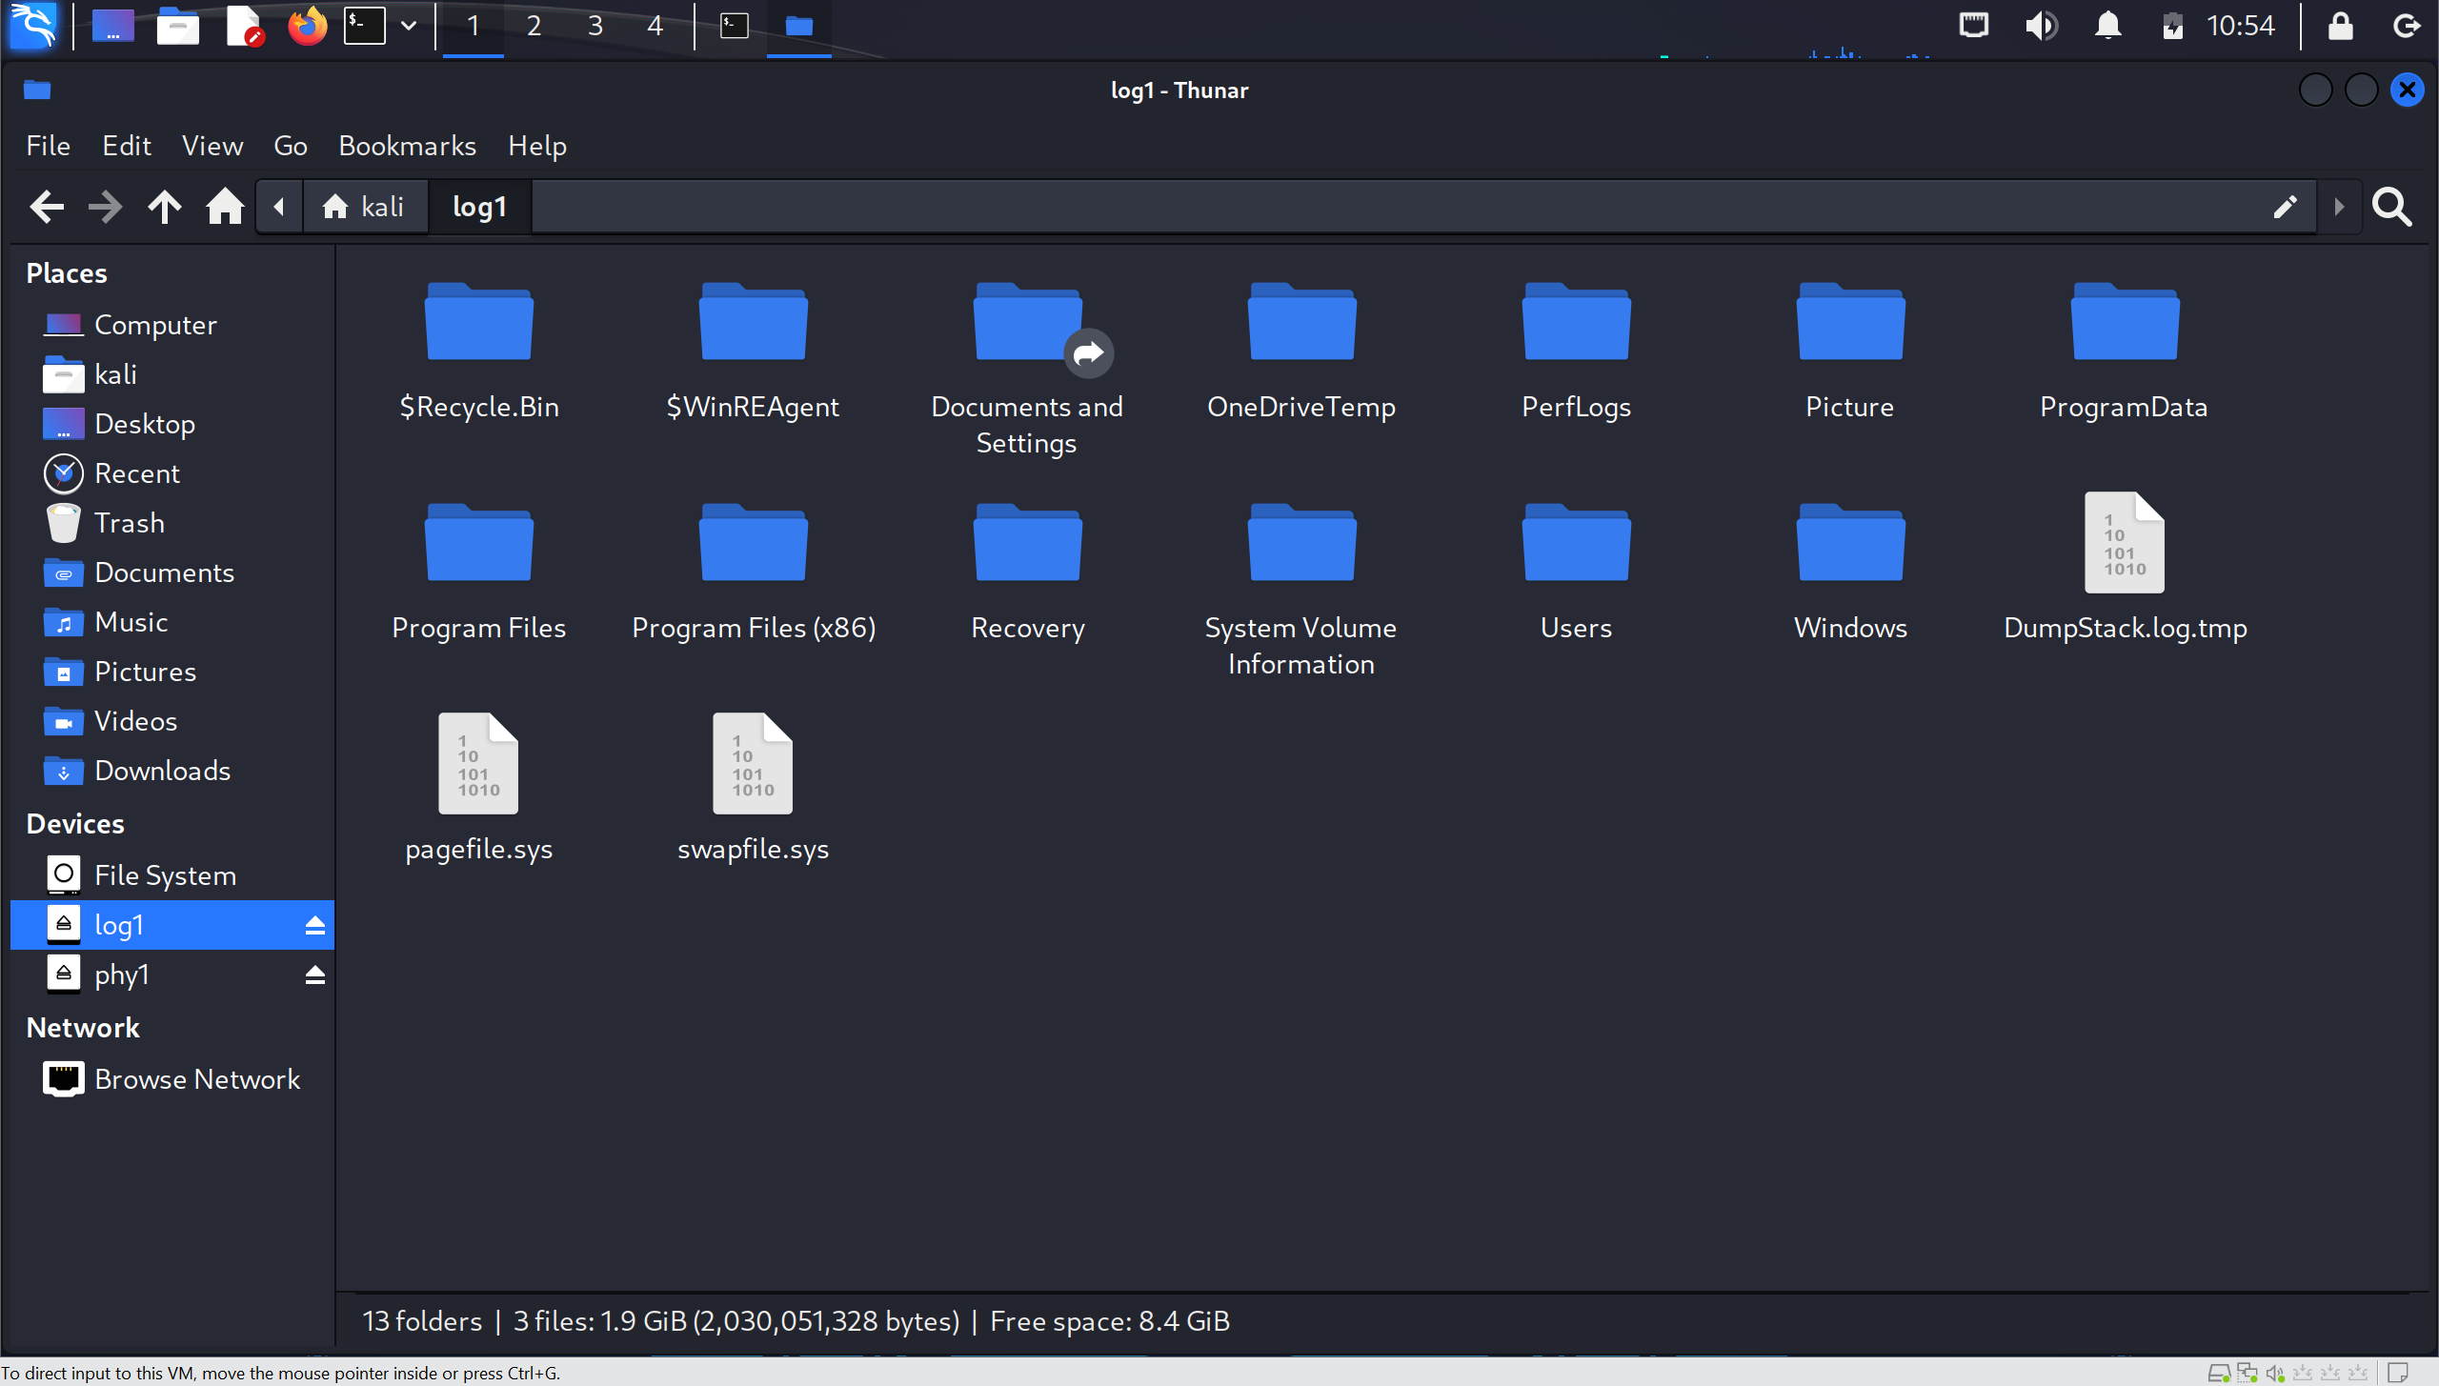

We can mount the evidence file on to our forensic workstation. It allows us to go through the directory of the evidence file easily in the file manager/terminal emulator, helping us to isolate the suspicious folder to extract out for further forensic investigations. We can also run keyword search and extension mismatch function easily when the file is mounted, instead of recovering the entire image and run, which takes a longer time. Useful when the evidence file is large. Additionally, these files that are mounted is read-only, this prevent accidental damage to the evidence file during forensic investigations, ensuring the integrity of evidence file.

# Tool Used

Built in commands such as Find and grep function, can be use as keyword or string search after mounting the evidence.

# Functionality of tools and how they help in my forensic investigation.

## Find and Grep

Can be used to search files by the filename.

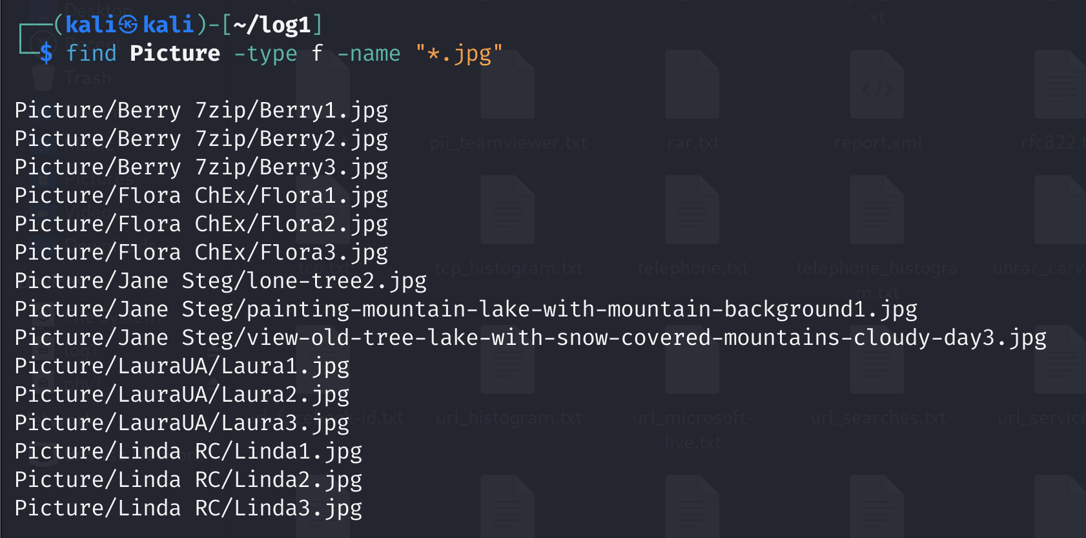

Search file using keywords found in the file.

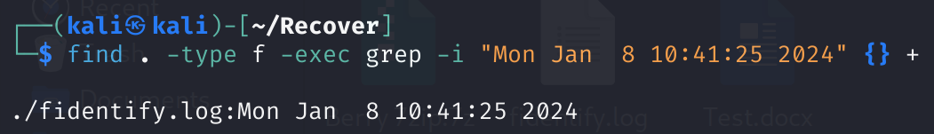

find . -type f -exec grep -i "Mon Jan 8 10:41:25 2024" {} +

Search file using a set of keywords stored in wordlist file.

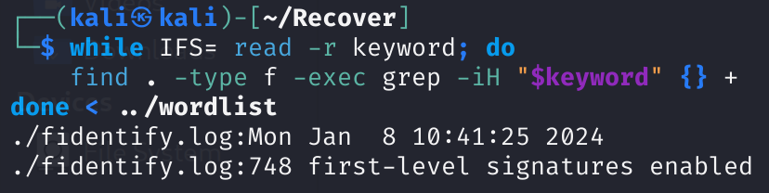

while IFS= read -r keyword; do

find . -type f -exec grep -iH "$keyword" {} +

done < ../wordlist

Use keyword or string search allow us to isolate the files that we need to focus on and recover easily and quickly. However, it may not work when the string is encoded or encrypted.

# Tool Used

Stegseek is a steganography brute-force utility to uncover hidden data inside files.

# Functionality of tools and how they help in my forensic investigation.

## Stegseek

A steghide cracker that can be used to extract hidden data from files.

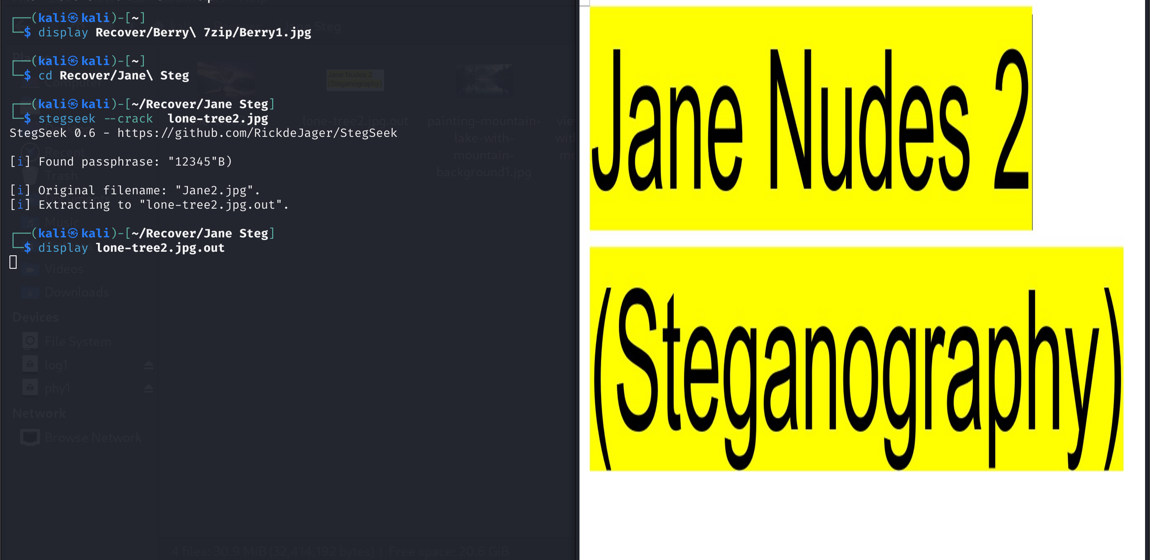

Suspect may use steghide command to file data in the file, to avoid detection from forensic investigator. Using stegseek, we can extract the hidden data from the file easily and crack the passphrase using the rockyou.txt which is a well-known password list with over 14 million passwords.

We can also come out with a custom password list for stegseek to run on.

# Similar tool

One similar tool is stegcracker.

Stegcracker can perform the same task as stegseek.

# Reasons for the tool

Stegseek performs the same task faster than stegcracker. Stegcracker takes 5 hours to complete the job while stegseek takes few seconds to complete it, greatly reducing the time needed for forensic in recovering data hidden by steghide in files.

# Tool Used

Fidentify which is a tool part of testdisk.

# Functionality of tools and how they help in my forensic investigation.

## fidentify

Display the actual extension(file type) of the given file.

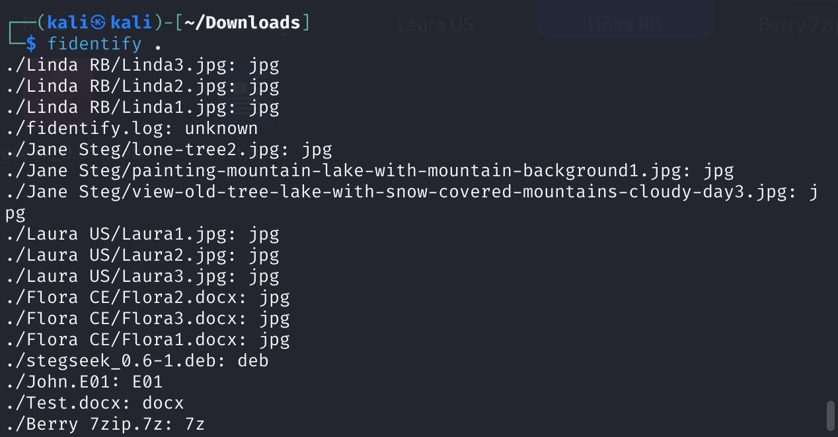

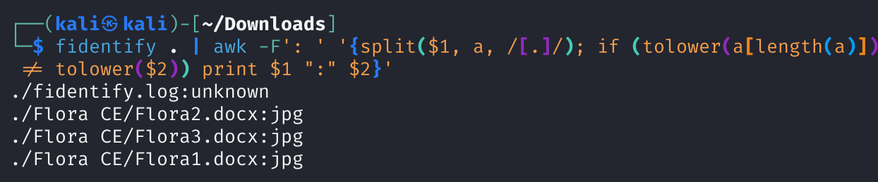

fidentify . | awk -F': ' '{split($1, a, /[.]/); if (tolower(a[length(a)]) != tolower($2)) print $1 ":" $2}'

fidentify . | awk -F': ' '!/unknown/ {split($1, a, /[.]/); if (tolower(a[length(a)]) != tolower($2)) print $1 ":" $2}'

This tool is useful for forensic investigator to detect files with mismatch extensions. Suspect may change the filename, including the extension, to something else to avoid suspicion and detection from forensic investigator. Using the tool will help forensic investigators to detect such files that indicates suspect’s malicious attempt of concealing the file.

# Similar tool

Built in File command is similar. However, fidentify is much simpler to manipulate to compare the actual extension and the file extension.

# Tool Used

Foremost is a forensic program to recover lost files based on their headers, footers, and internal data structures.

# Functionality of tools and how they help in my forensic investigation.

## foremost

Recover files using their headers, footers, and data structures.



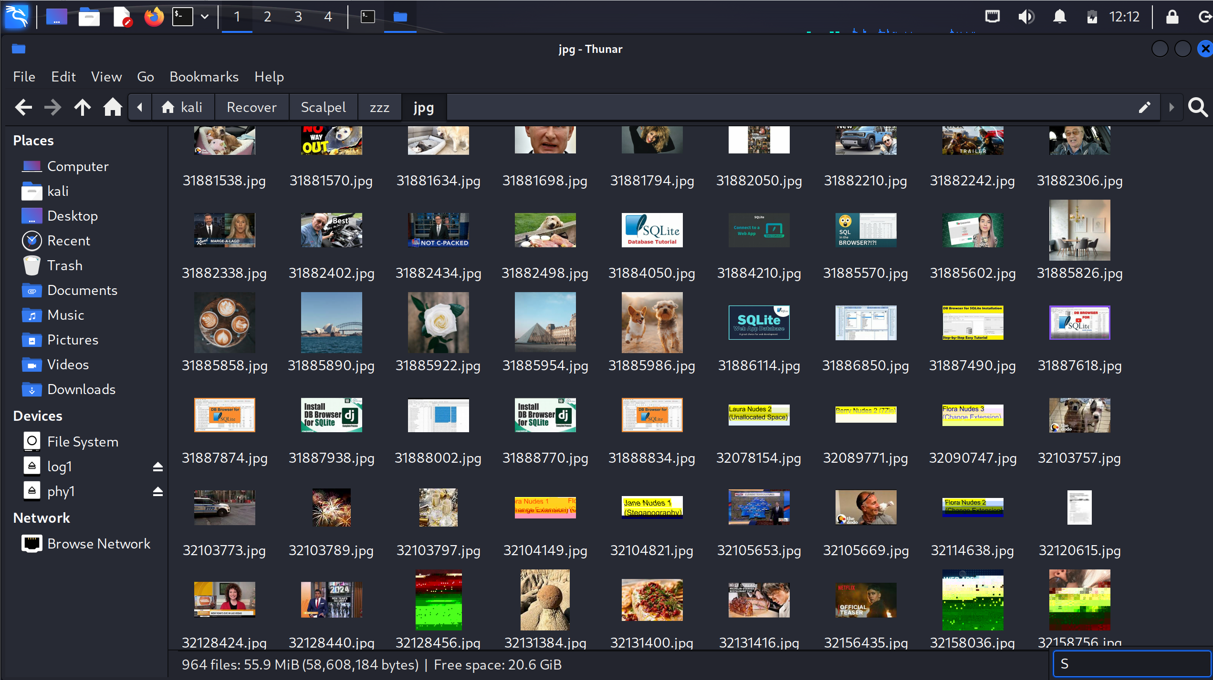

I can recover files based on file types, instead of the whole folder.

# Similar tool

TSK. The tsk_recover command in TSK can recover the unallocated /allocated /whole directory.

# Reasons for the tool

This help me to reduce workload if the case requirement is to recover certain files type such as jpg. Additionally, it can work on image files, such as those generated by dd, Safeback, Encase, etc, or directly on a drive. The headers and footers can be specified by a configuration file or you can use command line switches to specify built-in file types. These built-in types look at the data structures of a given file format allowing for a more reliable and faster recovery.

# Tool Used

Exiftool is a customizable set of Perl modules plus a full-featured command-line application called exiftool for reading and writing meta information in a wide variety of files, including the maker note information of many digital cameras by various manufacturers such as Canon, Casio, DJI, FLIR, FujiFilm, GE, HP, JVC/Victor, Kodak, Leaf, Minolta/Konica-Minolta, Nikon, Nintendo, Olympus/Epson, Panasonic/Leica, Pentax/Asahi, Phase One, Reconyx, Ricoh, Samsung, Sanyo, Sigma/Foveon and Sony.

# Functionality of tools and how they help in my forensic investigation.

## Exiftool

Read and write meta information in files.

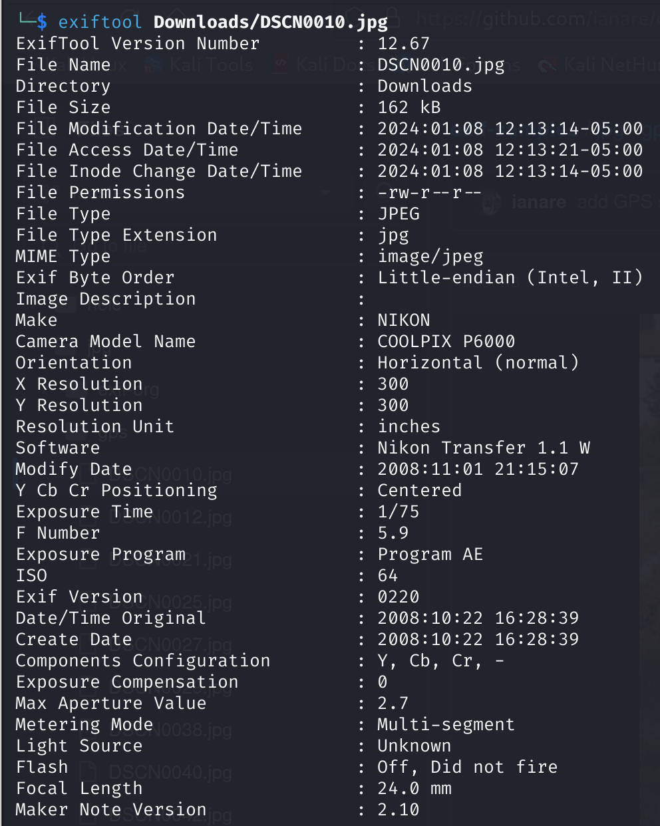

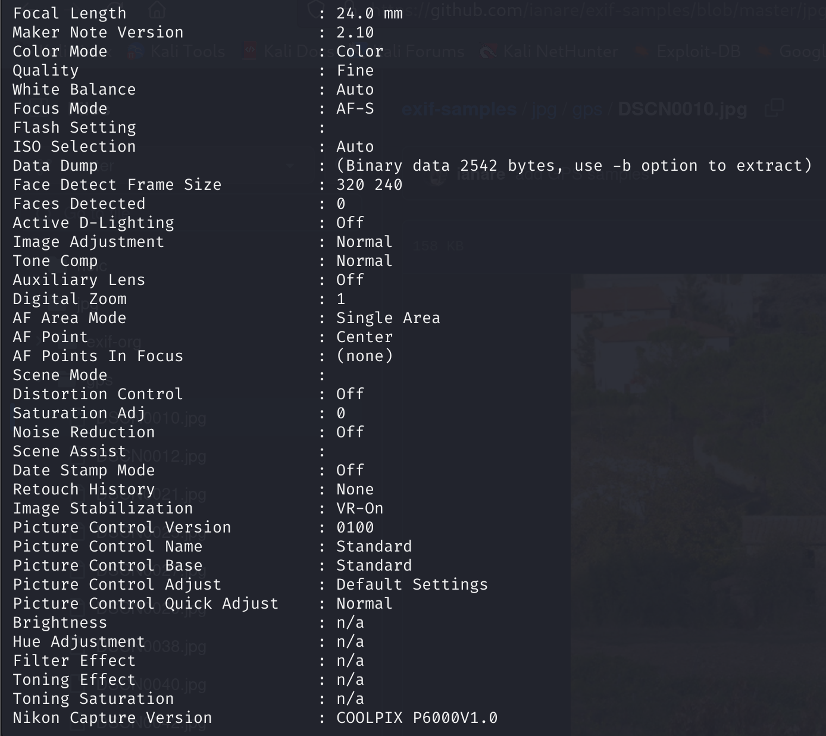 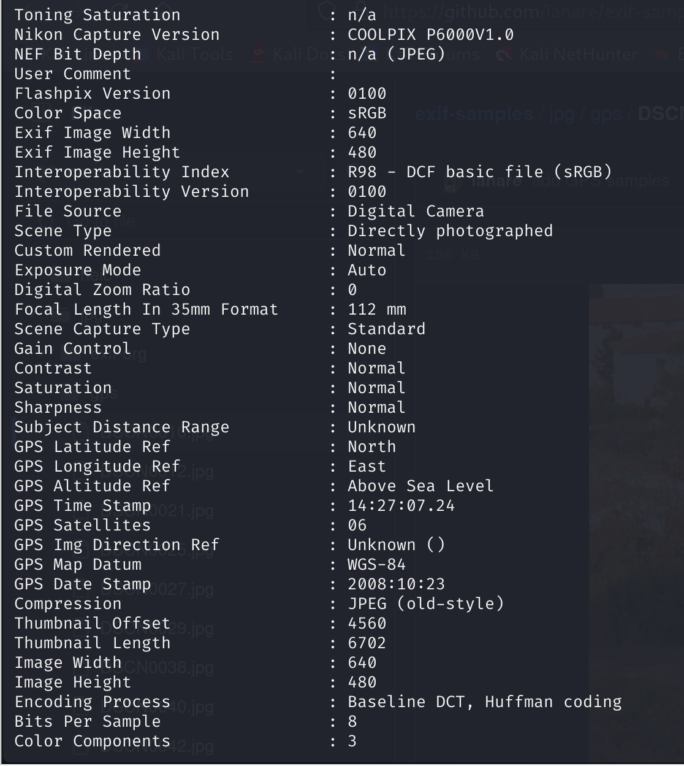

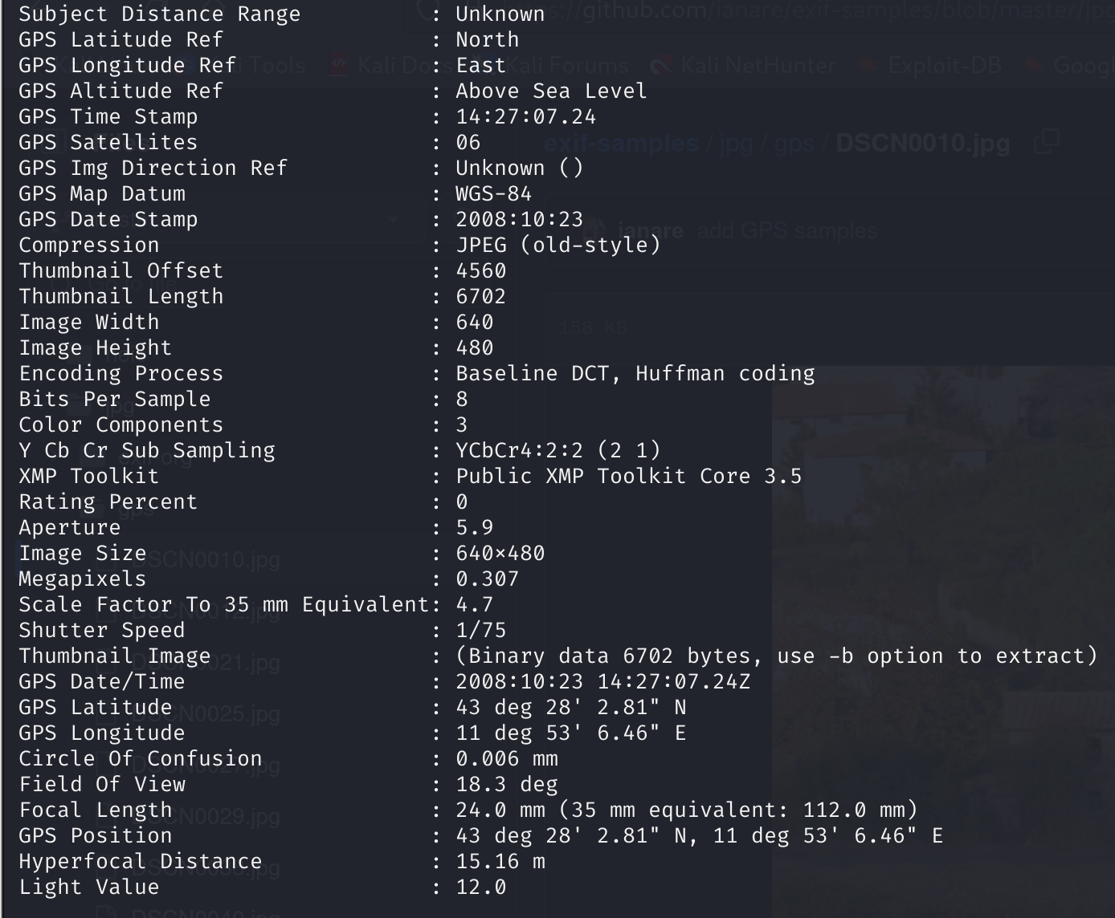

This shows exif data regarding to images. We can use this to analyse images recovered from suspect computer, getting important information such as geographical location and camera model used to take the photo. This information can be used to serve as evidence that suspect is unable to deny.

# Similar tool

Exiv2 is a C++ library and a command line utility to manage image metadata. It provides fast and easy read and write access to the Exif, IPTC and XMP metadata of images in various formats.

# Reasons for the tool

Exiftool is able to output more information than Exiv2. Which makes this tool more useful and preferred during forensic investigations.

# Other tools

## Hexeditor

View the file in hex view.

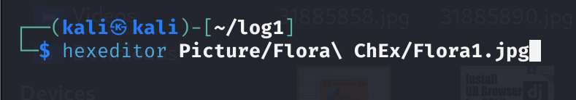

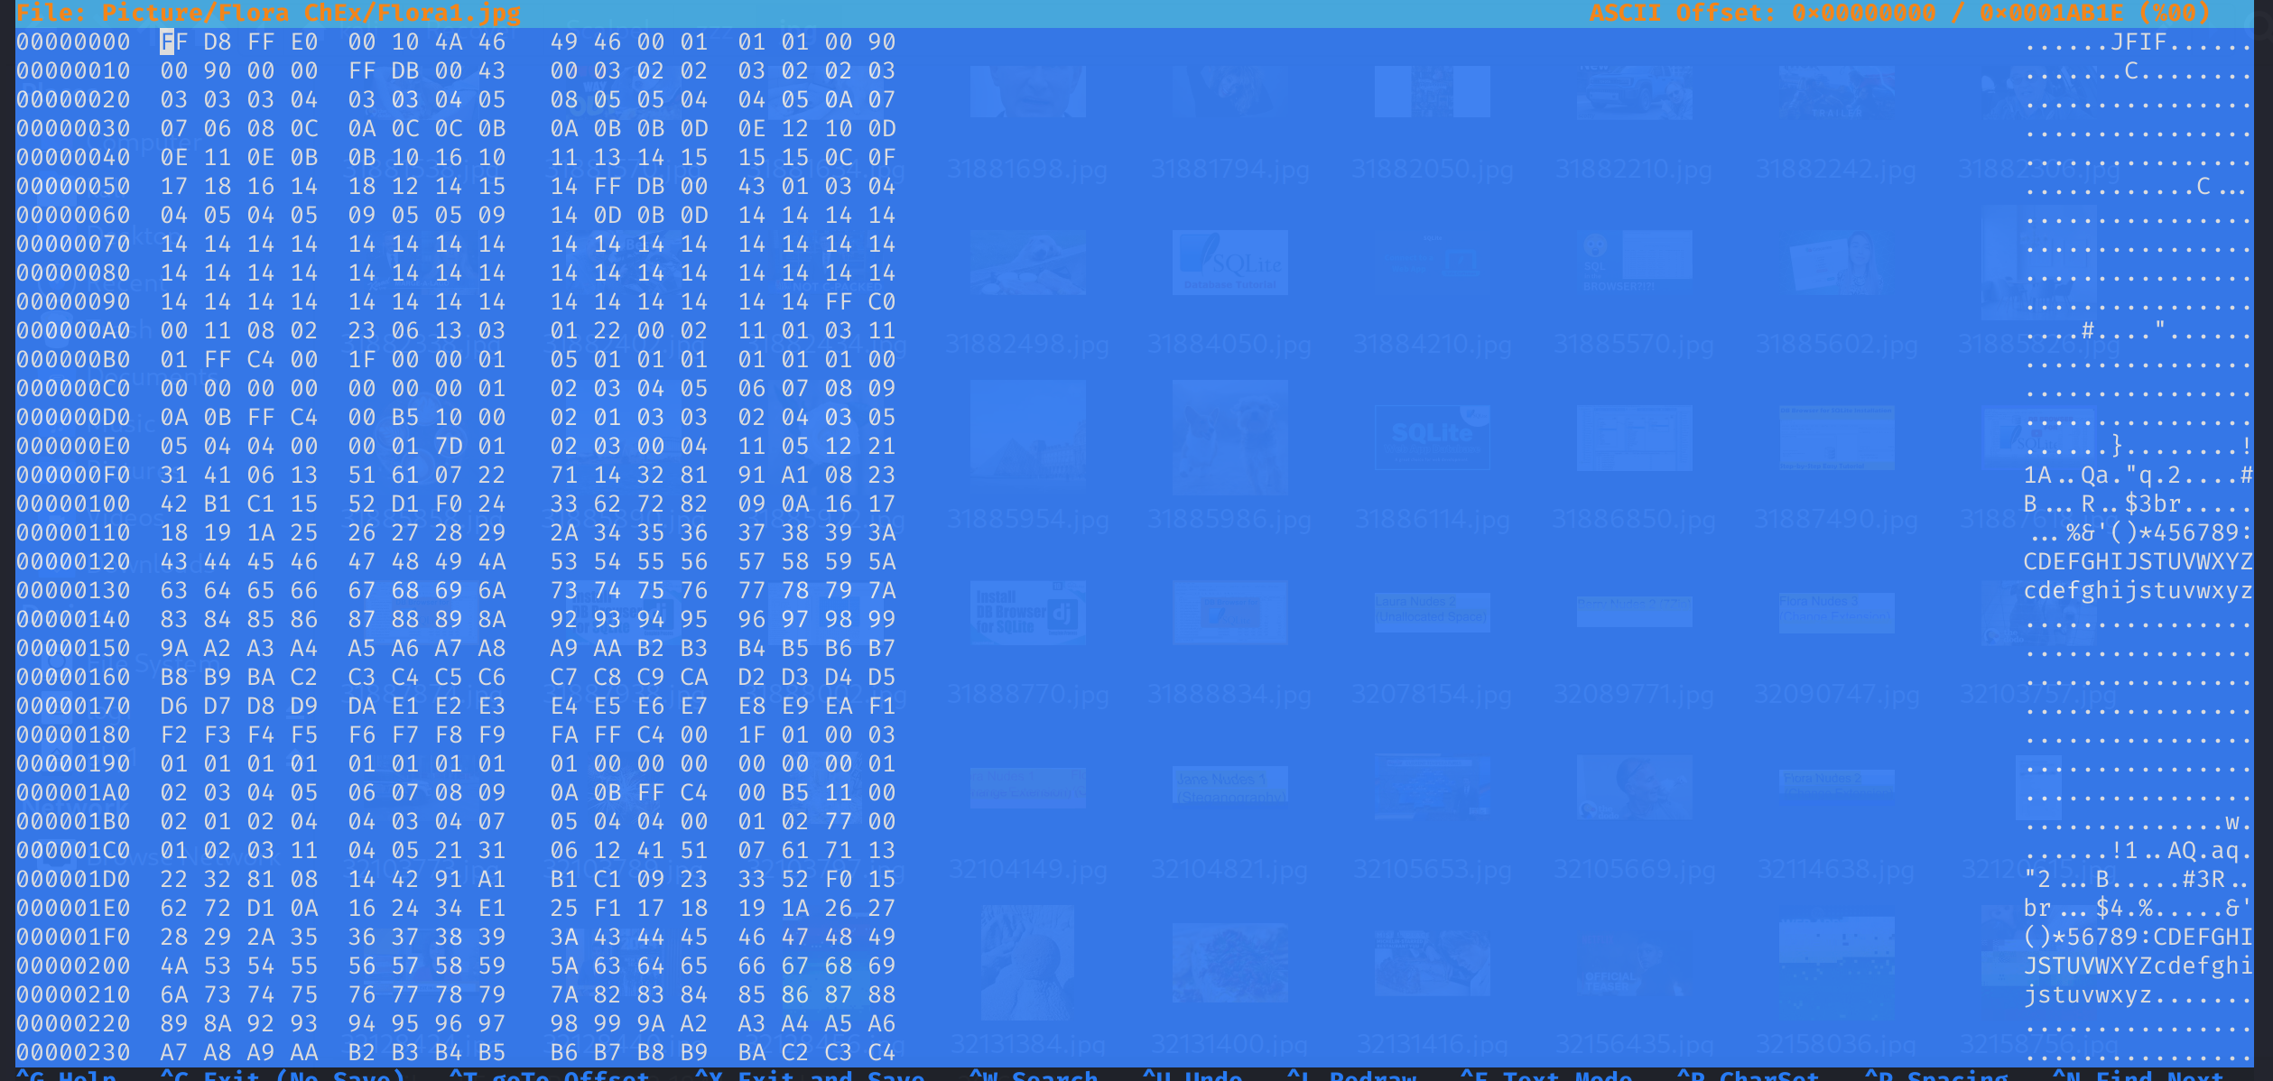

## Sqlitebrowser

View sqlite database

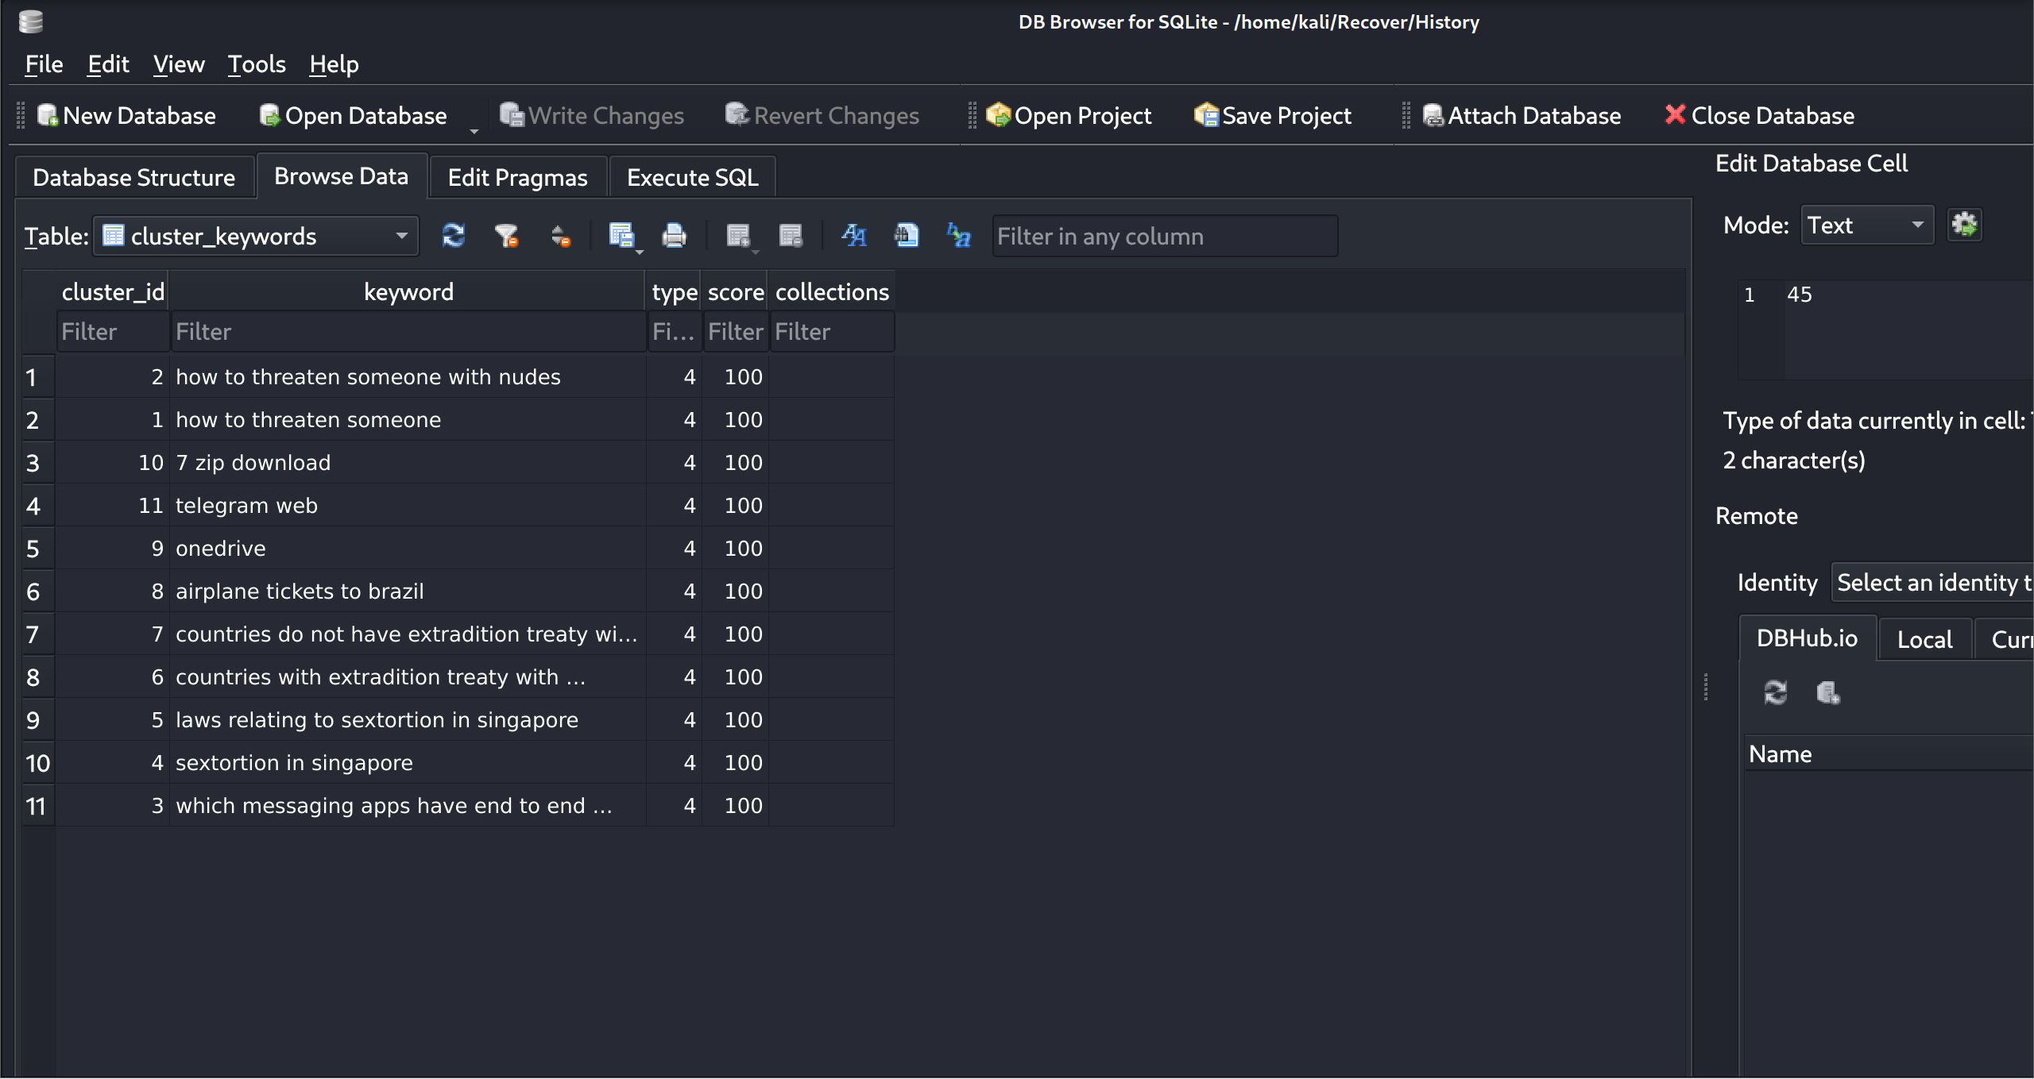

Useful for viewing browsing history related files. These files are important as it can be evidence to prove their intention/actions.

## John

Use to crack password-protected files.

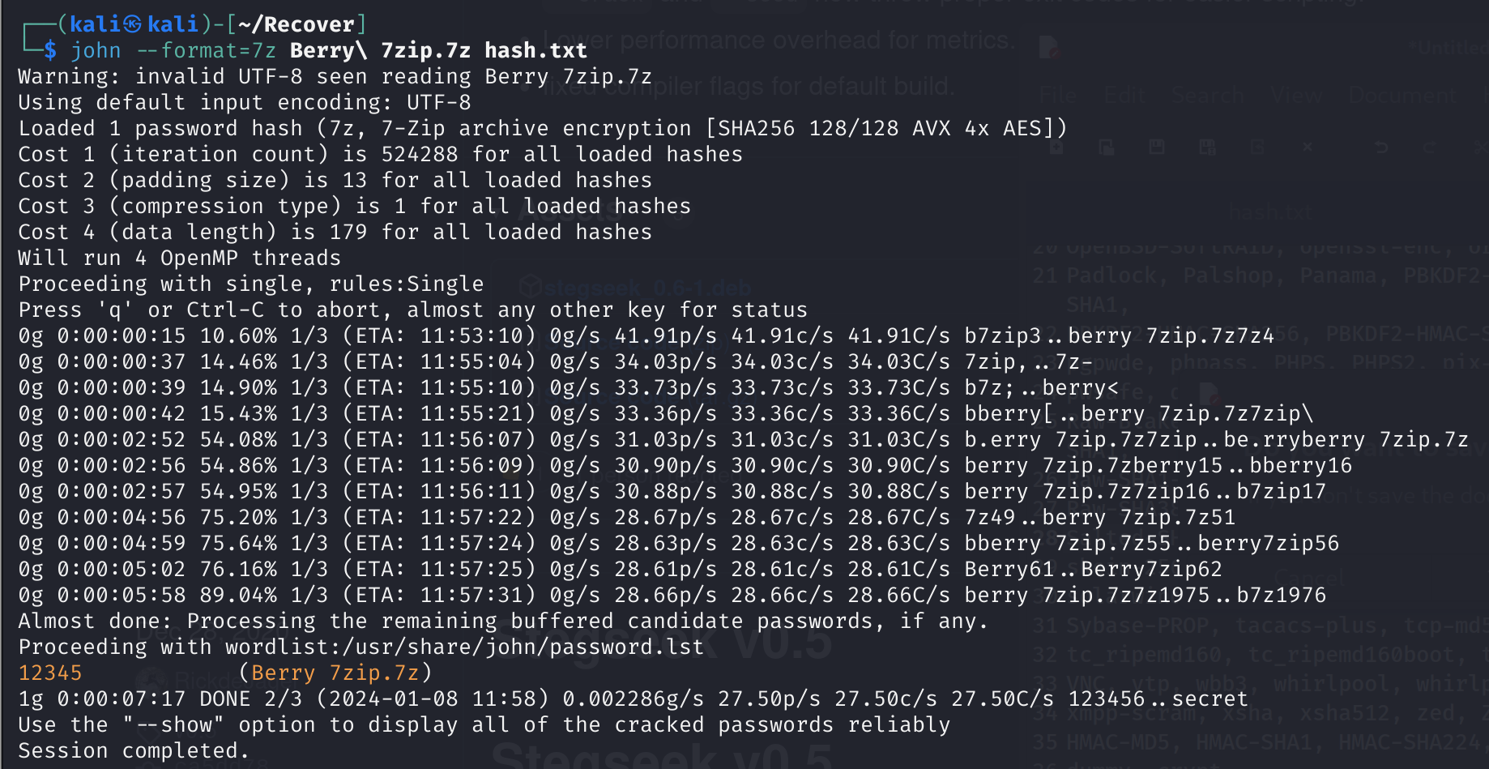

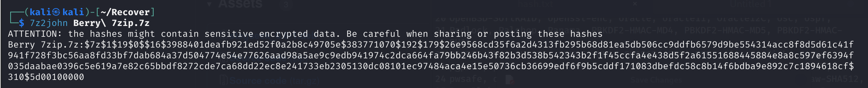

# Reference

<https://www.kali.org/tools/bulk-extractor/>

<https://www.sleuthkit.org/autopsy/>

<https://www.autopsy.com/>

<https://www.kali.org/tools/sleuthkit/>

<https://www.sleuthkit.org/>

<https://www.kali.org/tools/libewf/>

<https://www.kali.org/tools/stegcracker/>

<https://www.kali.org/tools/exiv2/>

<https://www.kali.org/tools/libimage-exiftool-perl/>

<https://www.kali.org/tools/john/>

<https://www.kali.org/tools/wordlists/>

<https://www.kali.org/tools/foremost/>

<https://github.com/RickdeJager/stegseek>

<https://www.kali.org/tools/sqlitebrowser/>

<https://www.kali.org/tools/ncurses-hexedit/#:~:text=Hexedit%20is%20a%20file%20editor,and%20full%20screen%20text%20snapshots>.

<https://www.kali.org/tools/testdisk/>

# Description of Demonstration

## Case scenario

Laura received a threatening message via Telegram from an unknown individual who possessed explicit photos of her, demanding payment of $5000 to prevent the dissemination of the images. In response, she promptly took a screenshot of the message and reported the incident to the police.

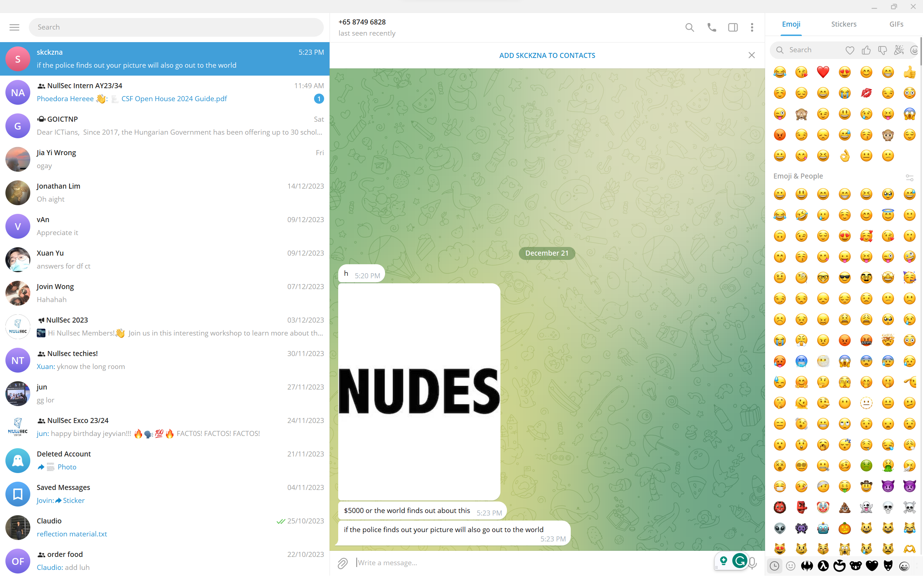

After a thorough investigation, law enforcement identified two primary suspects, John (Laura's ex-boyfriend) and Ben (her current boyfriend), as individuals with a significant likelihood of possessing the compromising photos. Subsequently, the police obtained and analyzed the computers of both suspects through forensic investigation procedures to gather evidence and determine the origin of the threat.

1. John’s personal computer running Windows 10 (20170316-001-E01) → Hard Disk (20170316-001-E01HD1) [image file: John.E01]
2. Ben’s personal computer running Windows 10 (20170316-001-E01) → Hard Disk (20170316-001-E01HD2) [image file: Ben.E01]

The preliminary interviews and investigations have gathered for John.

|  |  |
| --- | --- |
| John Doe | Ben frank |
| * 44 years old * Singaporeans * Male * Single * Chief executive officer of Leaked Pte Ltd   + Working hour: Mon-Fri, 10am to 5pm * Known software used:   + Windows   + Google Chrome * Online aliases   + Email: john1j2@outlook.com | * 44 years old * Singaporeans * Male * Single * Accountant of KoKonut Pte Ltd   + Working hour: Mon-Fri, 11am to 9pm * Known software used:   + Windows   + Google Chrome * Online aliases   + Email: bigbenz291@outlook.com |

## Source of evidence file

I plan to create my own evidence file for the investigation.

## How to create the evidence file

1. Download a Windows 10 ISO file from online.
2. Convert it into a VM and start running the VM.
3. Go and search for articles and laws relating to sextortion on VM.
4. Download the images for sextortion from onedrive to the VM.
5. Send the pictures to the victim via web telegram and threatened the victim.
6. Use FTK imager to extract the VM and convert it into a E01 file as evidence file for forensic investigation.

## Physical setup (with a list of resources) for the demo

* A computer with enough space to host multiple VMs.

## Other details such as diagram, activity flow chart